DAY 2: Evening Assesment

1. Create a tuple with 5 numbers and print the first and last elements.

t = (10, 20, 30, 40, 50)

print(t[0], t[-1])

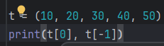

2. Write a Python program to check if an element exists in a tuple.

t = (10, 20, 30, 40, 50)

print(30 in t)

 

3. How can you find the length of a tuple?

t = (10, 20, 30, 40, 50)

print(len(t))

 

4. Write a program to convert a tuple into a list.

t = (10, 20, 30, 40, 50)

l = list(t)

print(l)

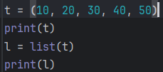 

5. Write a Python code to repeat a tuple 3 times.

t = (10, 20, 30, 40, 50)

print(t*3)

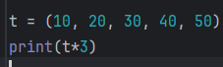 

6. What happens if you try to change an element of a tuple? Explain with example.

tuple element is Immutable

t = (10, 20, 30, 40, 50)

t[0] = 100 → This will raise a TypeError

7. Write a Python program to concatenate two tuples.

t=(1,2)

t1=(3,4)

print(t+t1)

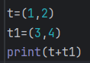 

8. How can you slice a tuple to get its first three elements?

t = (10, 20, 30, 40, 50)

print(t[0:3])

 

9. Create a set with strings and print all elements.

set={"app", "ball", "box"}  
print(set)

 

10. Write a program to add multiple elements to a set using `update()`.

s = {1, 2, 3}

s.update({4, 5})

print(s)

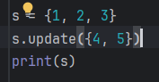 

11. Write a program to check if an element is present in a set.

t = {10, 20, 30, 40, 50}

print(20 in t)

 

12. Write a Python code to find the difference between two sets `{1, 2, 3, 4}` and `{3, 4, 5}`.

a = {1, 2, 3, 4}

b = {3, 4, 5}

print(a - b)

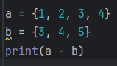 

13. What is the symmetric difference of two sets? Write a program for it.

a = {1, 2, 3}  
b = {2, 4}  
print(a.symmetric_difference(b))

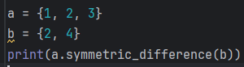 

14. Can a set contain duplicate elements? Explain with example.

Set can't have duplicates

dup = {1, 2, 2, 3}

print(dup)

 

15. How do you clear all elements from a set?

dup = {1, 2, 2, 3}

dup.clear()

print(dup)

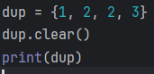 

16. Write a program to copy a set to another set.

dup = {1, 2, 2, 3}

copy=dup.copy()

print(copy)

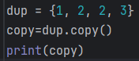 

17. Write a program to compare two integers and print if they are equal or not.

a, b = 10, 20

if(a==b):

print(“Equal”)

else:  
 print("Not Equal")

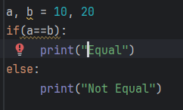 

18. What is the output of `10 != 5`?

True

19. How do you check if a number is less than or equal to another number?

a,b=10,20

print(a<=b)

 

20. Write a program to compare two strings entered by the user using `==`.

str1 = input("Enter first string: ")

str2 = input("Enter second string: ")

if (str1 == str2):

print("Equal")  
else:  
 print("Not Equal")

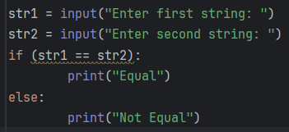 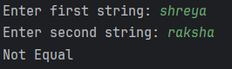

21. What is the difference between `>` and `>=` operators?

> checks strictly greater

>= includes equal

22. Write a program to check if `a` is not equal to `b`.

a,b=10,20

print(a != b)

 

23. Write a program to compare the lengths of two input strings.

x = input("Enter string 1: ")

y = input("Enter string 2: ")

if len(x) > len(y):  
 print(“x is greater”)

else:

print(“y is greater”)

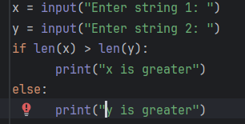 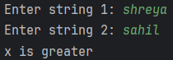

24. Write a program to check if the first number is greater than the second and print an appropriate message.

n1 = int(input("Enter number 1: "))

n2 = int(input("Enter number 2: "))

if n1 > n2:

print("First is greater")

else:

print("Second is greater or equal")

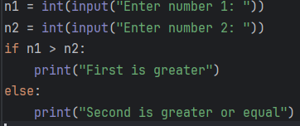 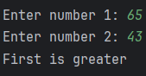

25. What will be the output of `True or False`?

True

print(True or False)



26. Write a Python condition using `and` that checks if a number is positive and less than 100.

num = int(input("Enter number: "))

if (num>0 and num<100):  
 print(“Valid”)

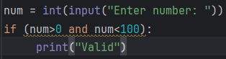 

27. Write a program to check if a character entered by the user is a vowel or consonant using logical operators.

ch = input("Enter a character: ").lower()

if ch in "aeiou":

print("Vowel")

else:

print("Consonant")

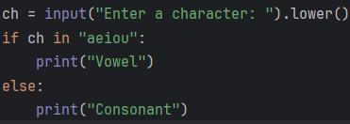 

28. How does the `not` operator work? Write an example.

f = False

print(not f) # True



29. Write a Python code using `or` to check if a number is divisible by 3 or 5.

n = int(input("Enter number: "))

if(n%3==0 or n%5==0):  
 print("Divisible by 3 or 5")

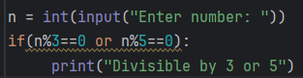 

30. Write a Python program to check if a number is between 50 and 100 (inclusive) using logical operators.

n = int(input("Enter number: "))

if(n>=50 and n<=100):  
 print("range")

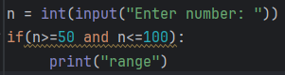 

31. Explain how `and`, `or`, `not` can be used in a single condition.

num = 5

if(num>0 and num<10)or not(num %2==0):

print("logical operators AND,OR,NOT can be handled in the single condition with control statement" )

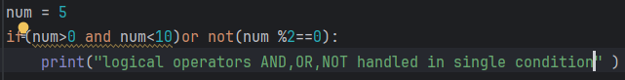



32. Write a program using `not` to check if a string is not empty.

s = input("Enter a string: ")

if not s == "":

print("Not empty")

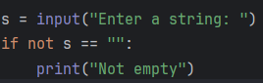 

33. Write a program to take a number from the user and print its square.

n = int(input("Enter number: "))

print(“square:”, n*n)

 

34. How do you take a floating-point number as input and print it?

n = float(input("Enter number: "))

print("Float:", f)

35. Write a program to take a space-separated list of integers from the user and print the maximum number.

l=list(map(int(input(“enter the integers”).split()))

print("Max:", max(l))

 

36. Write a Python program to read a string from the user and print its length.

s = input("Enter string: ")

print("Length:", len(s))

 

37. Write a program to input two numbers and print their product.

a = int(input("Enter first: "))

b = int(input("Enter second: "))

print("Product:", a * b)

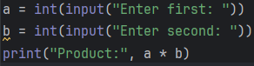 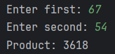

38. Write a program to input a number and check if it is positive, negative, or zero.

n = int(input("Enter number: "))

if n > 0:

print("Positive")

elif n < 0:

print("Negative")

else:

print("Zero")

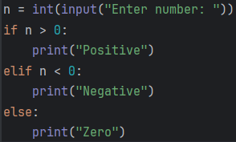 

39. Write a program to take the user's full name as input and display it in uppercase.

name=input('enter the full name')  
print(name.upper())

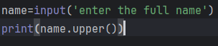

40. Write a program to take a sentence from the user and count the number of words.

sen = input(“enter the sentences”)

print(“word count” , len(sen.split()))



